हिन्दू विद्या निकेतन
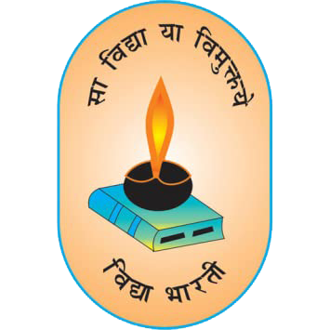

केन्द्रीय माध्यमिक शिक्षा बोर्ड, नई दिल्ली
हिन्दू शिक्षा समिति हरियाणा द्वारा संचालित
सम्बद्धता सं०- 531882 मो०- 9050153072
क्रमांक :……………
दिनांक : 01.07.2026

School Safety Committee
School Safety Committee has been constituted at school level with following member :-
S.NO. | NAME | DESIGNATION | MOBILE NO.
1 | Dr. Prithvi Raj Kaushal | Principal | 9671464821
2 | Mr. Rajveer Singh | TGT ( Maths ) | 8053610620
3 | Mrs. Sonia | Co - ordinator | 9050206218
4 | Mrs. Annu | School Safety Committee | 7988615804

नूहं, जिला नूहं ( हरियाणा )– 122107
Email :hinduvidyaniketannuh@gmail.com
Website : www.hinduvidyaniketan.com

