हिन्दू विद्या निकेतन
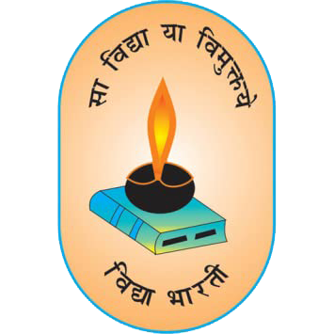
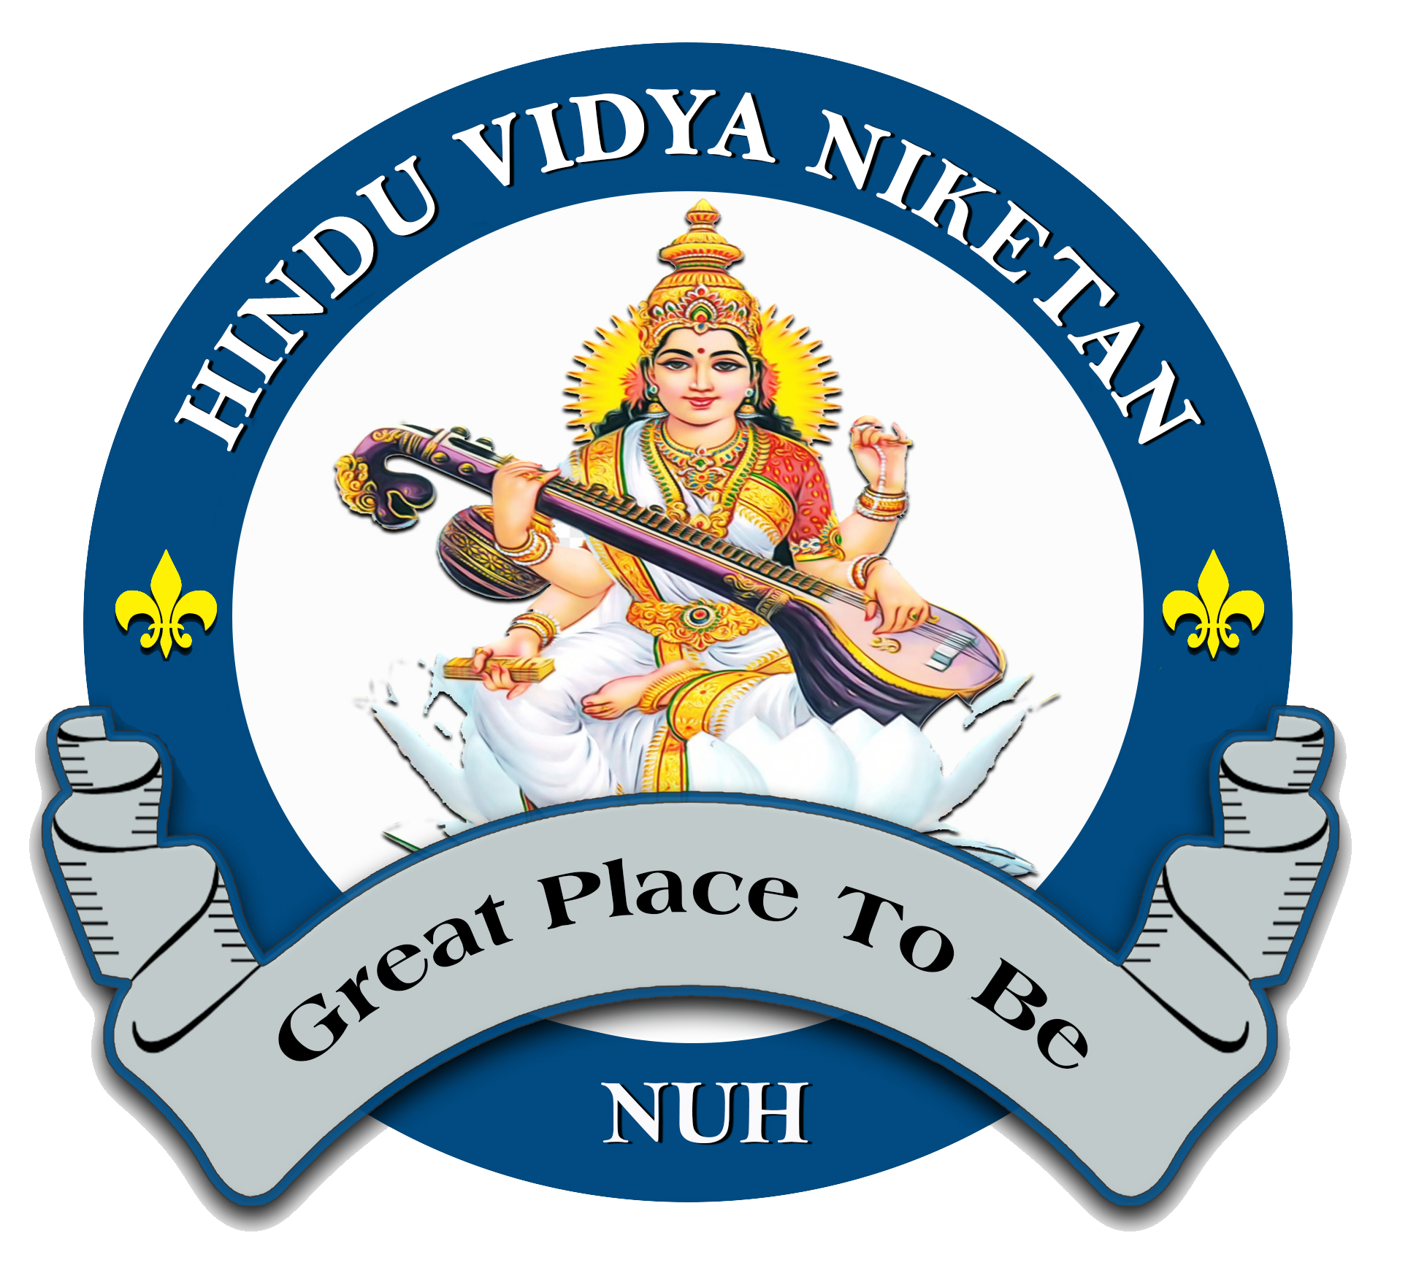
केन्द्रीय माध्यमिक शिक्षा बोर्ड, नई दिल्ली
हिन्दू शिक्षा समिति हरियाणा द्वारा संचालित
सम्बद्धता सं०- 531882 मो०- 9050153072
क्रमांक :……………
दिनांक : 01.07.2026

Sexual Harassment Committee
Sexual Harassment Committee has been constituted following member :-
S.NO. | NAME | DESIGNATION | MOBILE NO.
1 | Smt. Pratima Manchanda Ji ( SMC ) | Chairperson | 9818488433
2 | Mrs. Jyoti Garg | Member | 9812155651
3 | Mrs. Kanchan | Member | 9813166529
4 | Mr. Krishan Kumar Chhimpa | Member | 9309339093
5 | Mr. Rajveer Singh | Member | 8053610620
Complaint Committee
S.NO. | NAME | DESIGNATION | MOBILE NO.
1 | Smt. Kavita ( SMC ) | Chairperson | 9991161343
2 | Smt. Chandni | Member | 8395960646
3 | Mr. Sagar Makkar | Member | 9896692304
4 | Mrs. Geeta | Member | 9671764624

नूहं, जिला नूहं ( हरियाणा )– 122107
Email :hinduvidyaniketannuh@gmail.com
Website : www.hinduvidyaniketan.com

